**Creating and Assuming an Administrator AWS IAM Role**

**Hands-on Lab**

In this Hands-on Lab we are going to work through creating a brand-new IAM Role. This IAM Role will be granted Administrator Access permissions within the same account.

**Objectives**

* Create IAM Role
* Assume the IAM Role
* Create & Deploy CloudFormation Template of IAM Role

**Architecture**

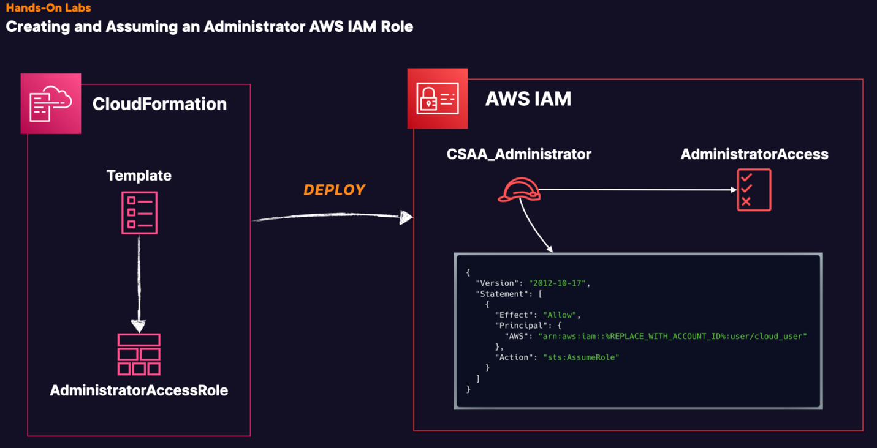

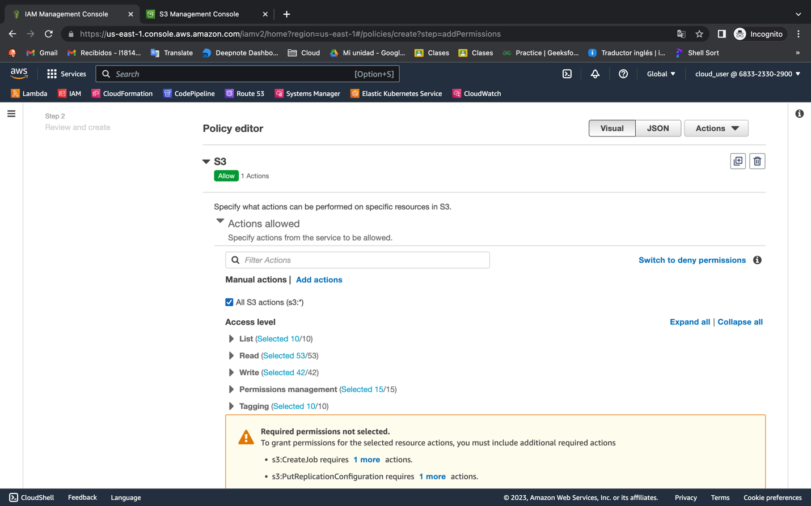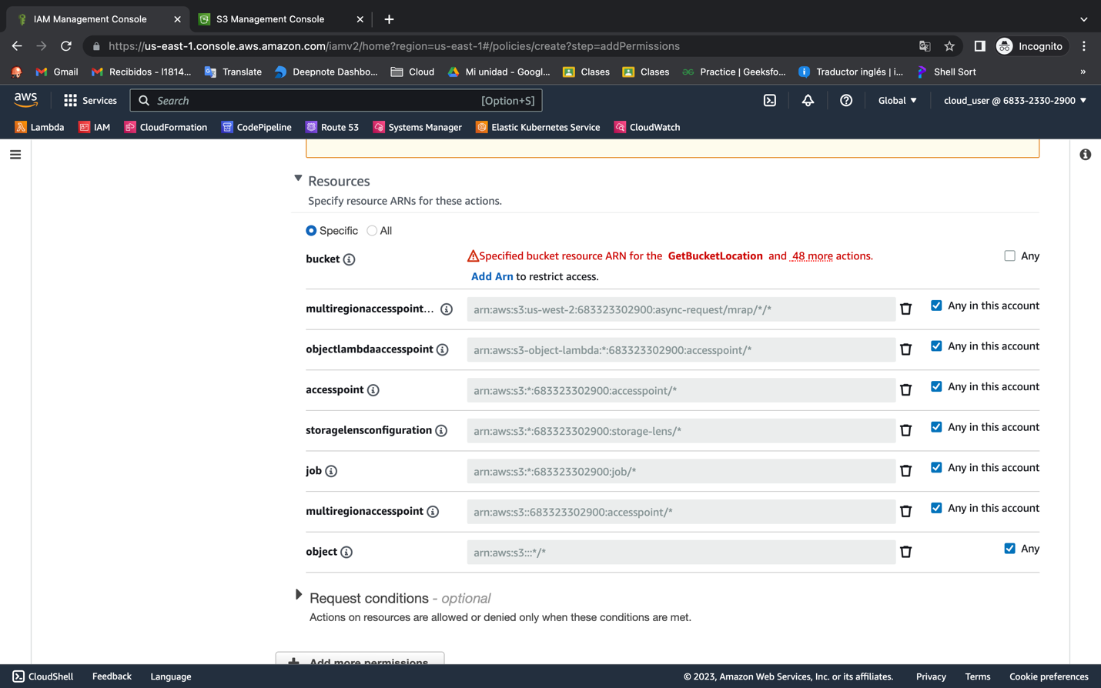

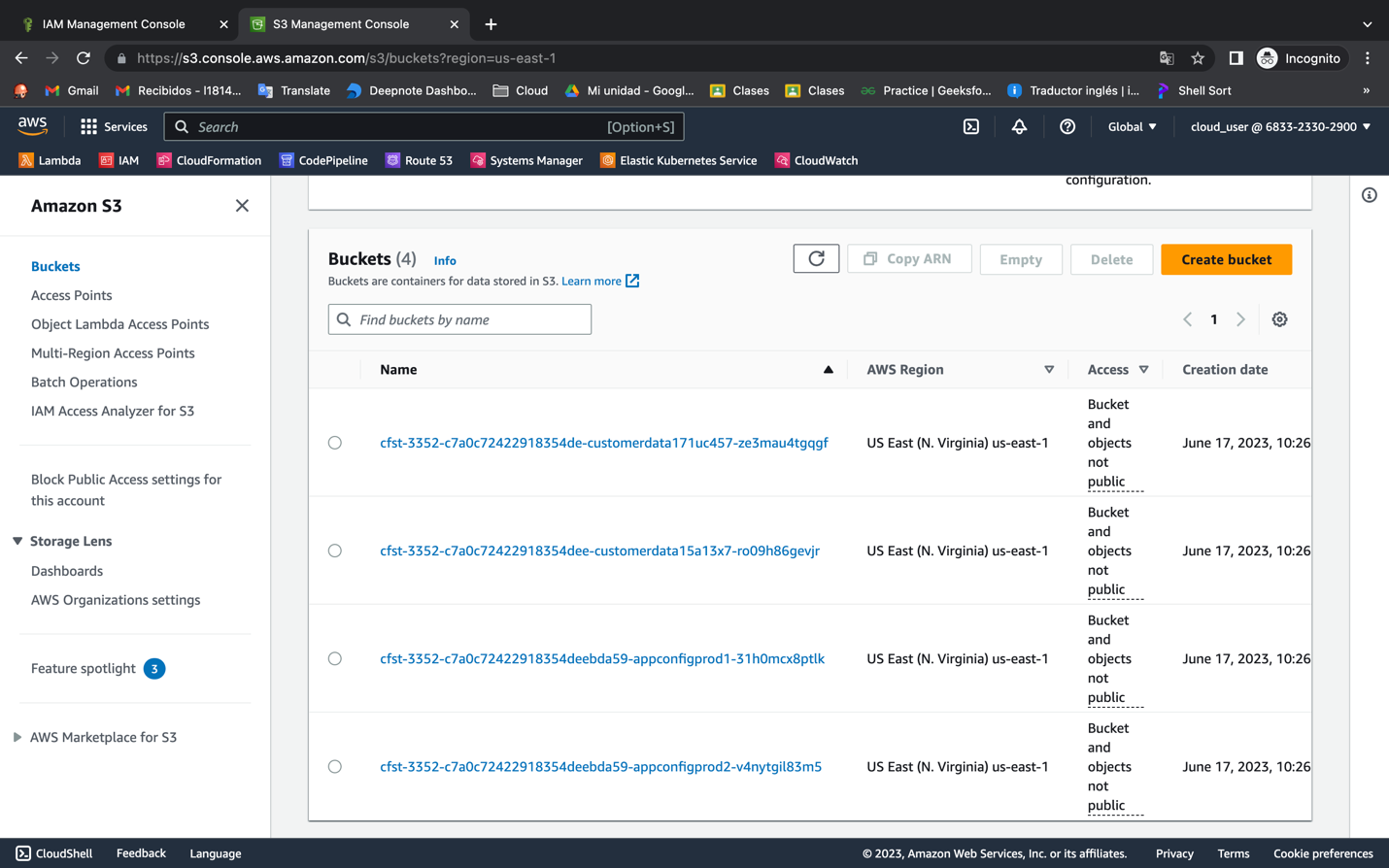

{

"Version": "2012-10-17",

"Statement": [

{

"Sid": "VisualEditor0",

"Effect": "Allow",

"Action": [

"s3:ListStorageLensConfigurations",

"s3:ListAccessPointsForObjectLambda",

"s3:GetAccessPoint",

"s3:PutAccountPublicAccessBlock",

"s3:GetAccountPublicAccessBlock",

"s3:ListAllMyBuckets",

"s3:ListAccessPoints",

"s3:PutAccessPointPublicAccessBlock",

"s3:ListJobs",

"s3:PutStorageLensConfiguration",

"s3:ListMultiRegionAccessPoints",

"s3:CreateJob"

],

"Resource": "*"

},

{

"Sid": "VisualEditor1",

"Effect": "Allow",

"Action": "s3:*",

"Resource": "arn:aws:s3::683323302900:accesspoint/*"

},

{

"Sid": "VisualEditor2",

"Effect": "Allow",

"Action": "s3:*",

"Resource": [

"arn:aws:s3-object-lambda:*:683323302900:accesspoint/*",

"arn:aws:s3:*:683323302900:storage-lens/*",

"arn:aws:s3:*:683323302900:accesspoint/*",

"arn:aws:s3:::*/*",

"arn:aws:s3:*:683323302900:job/*",

"arn:aws:s3::: cfst-3352-c7a0c72422918354deebda59-appconfigprod1-31h0mcx8ptlk",

"arn:aws:s3:::cfst-3352-c7a0c72422918354deebda59-appconfigprod2-v4nytgil83m5",

"arn:aws:s3:us-west-2:683323302900:async-request/mrap/*/*"

]

}

]

}

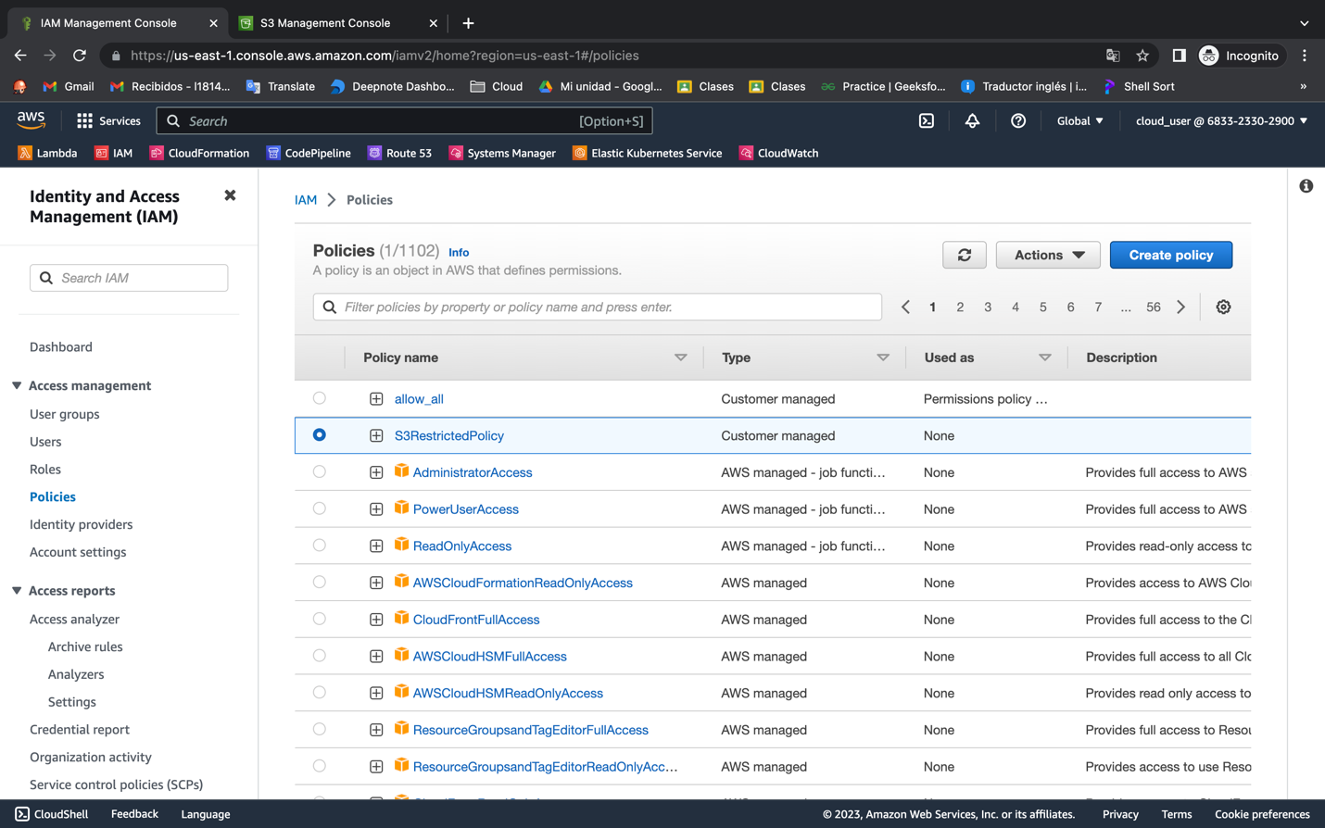

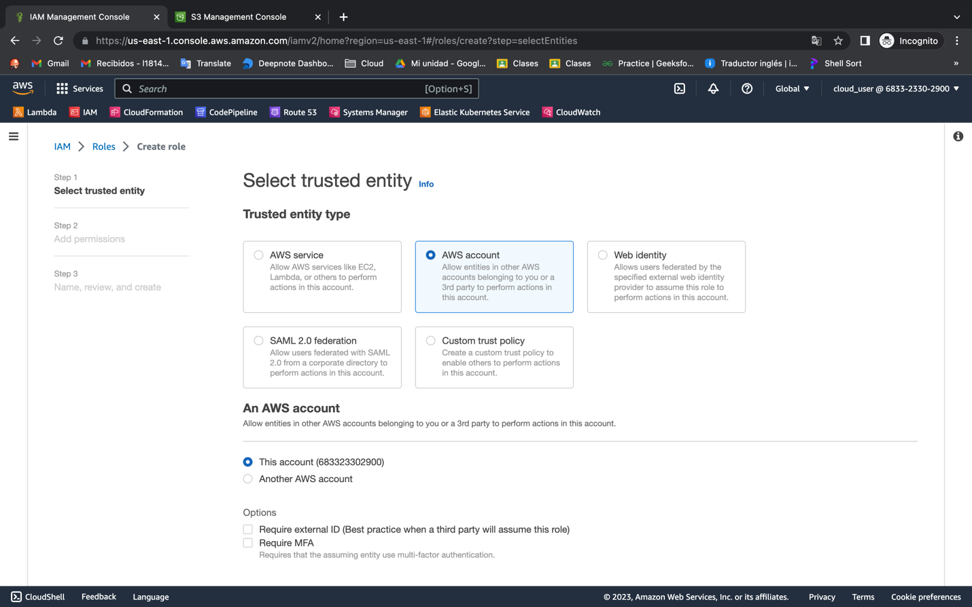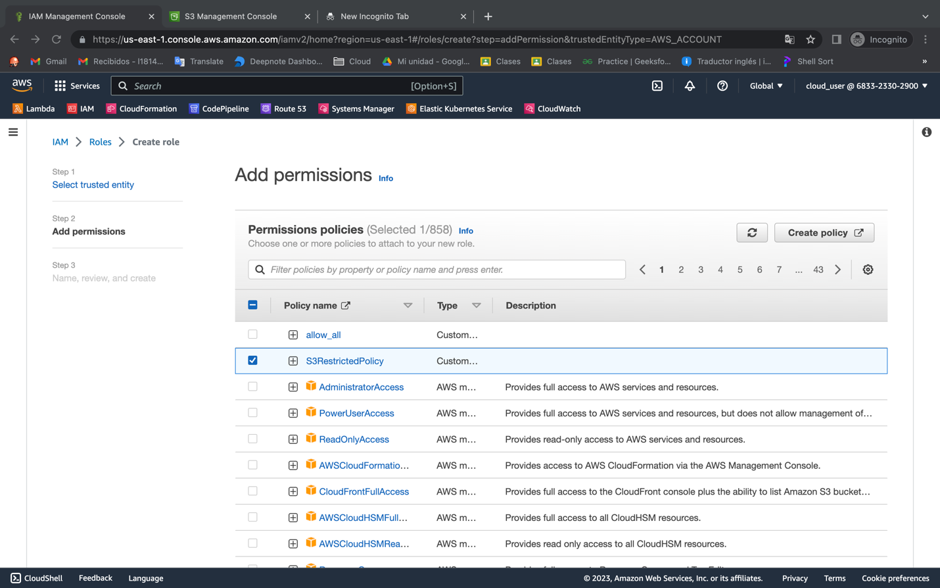

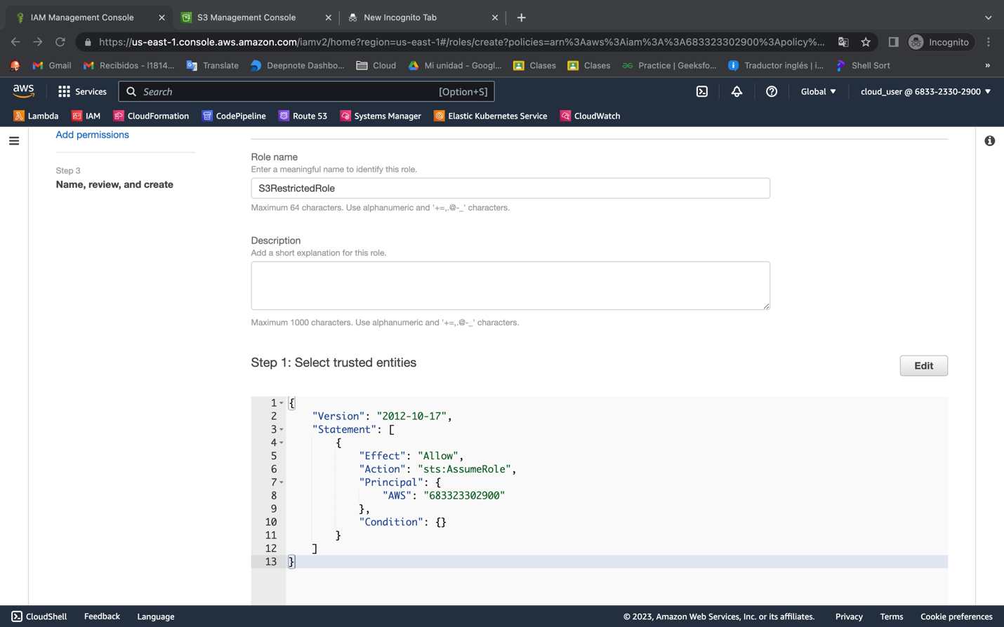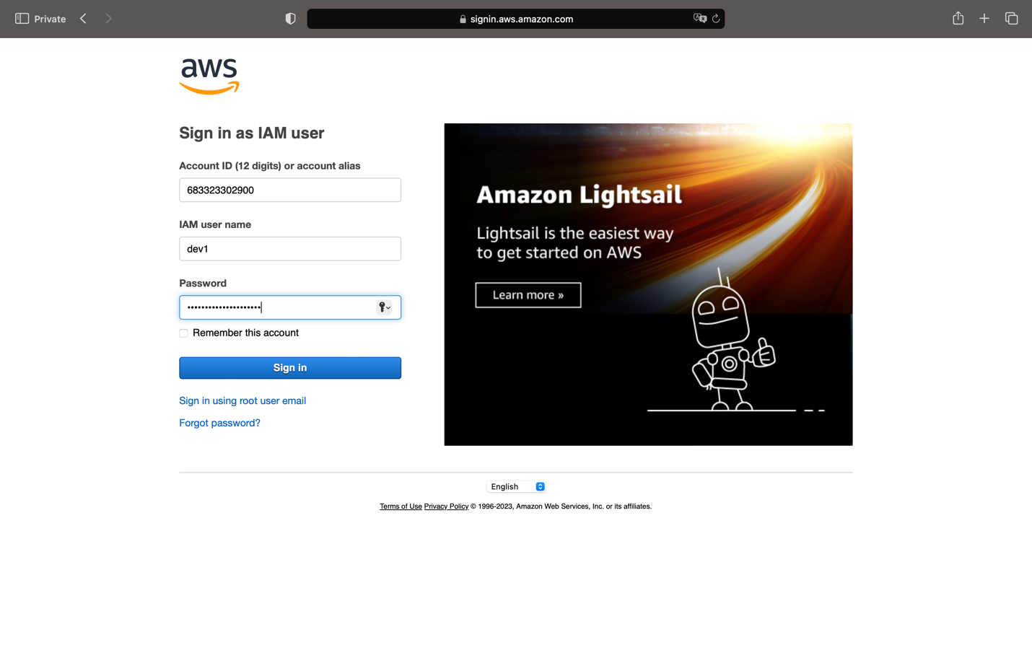

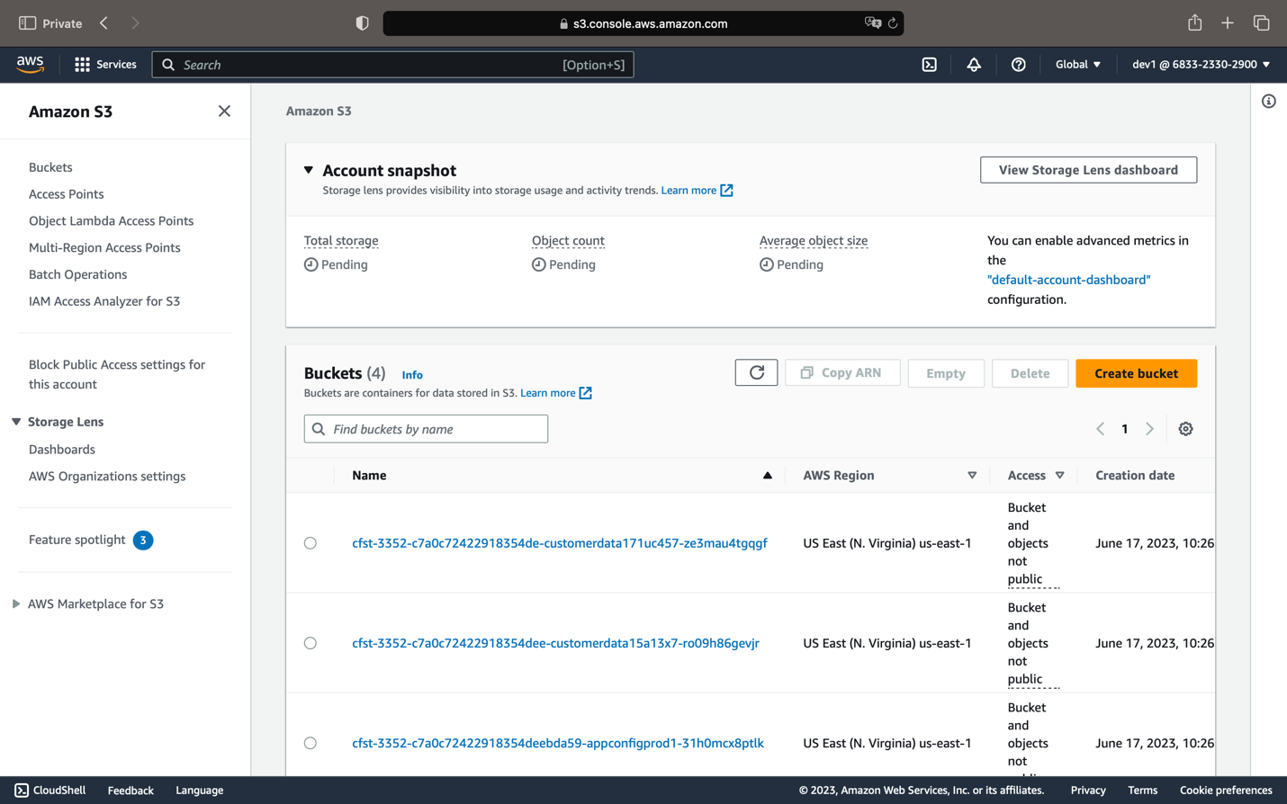

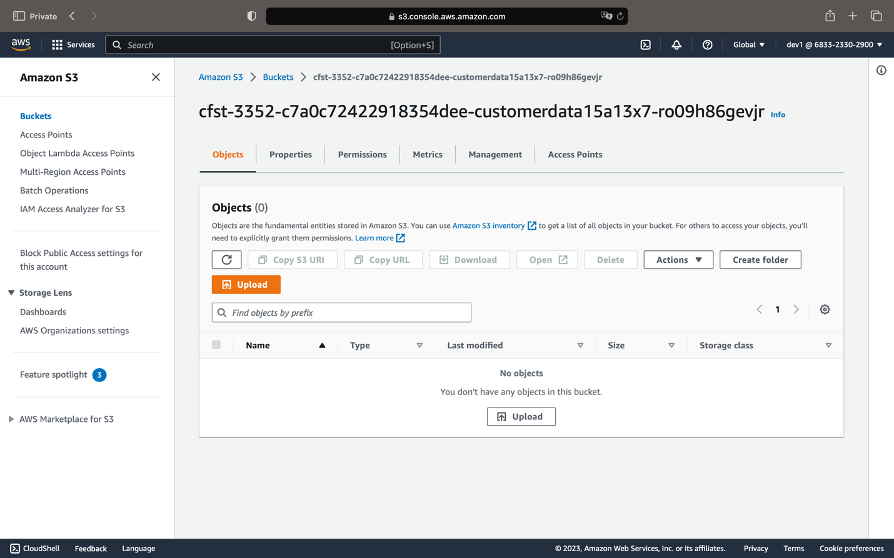

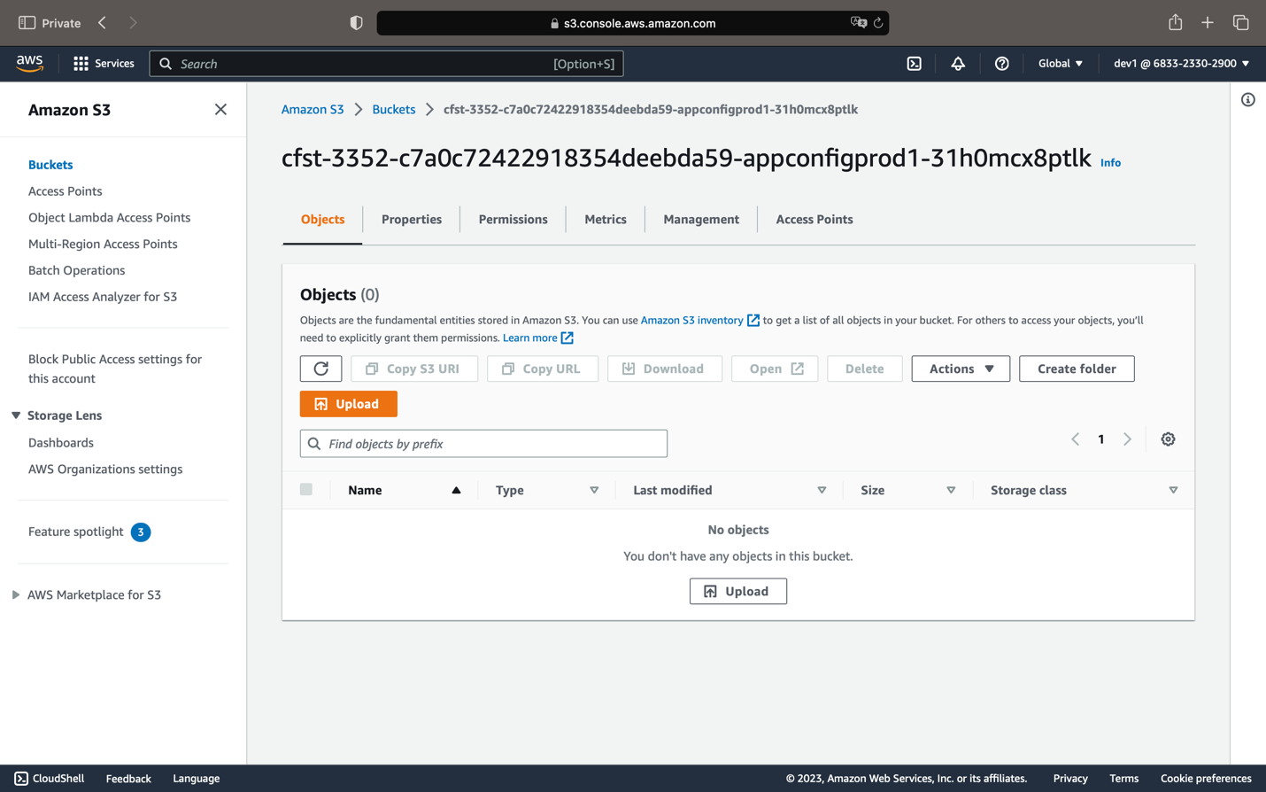

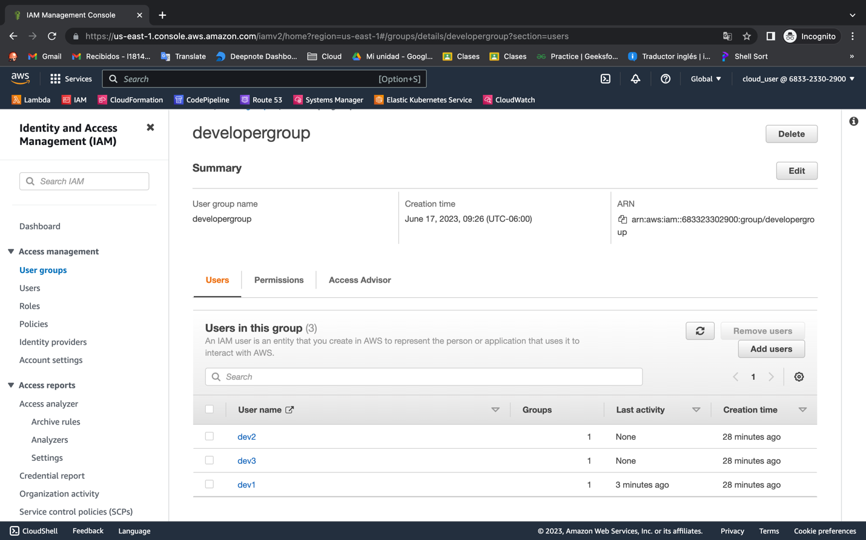

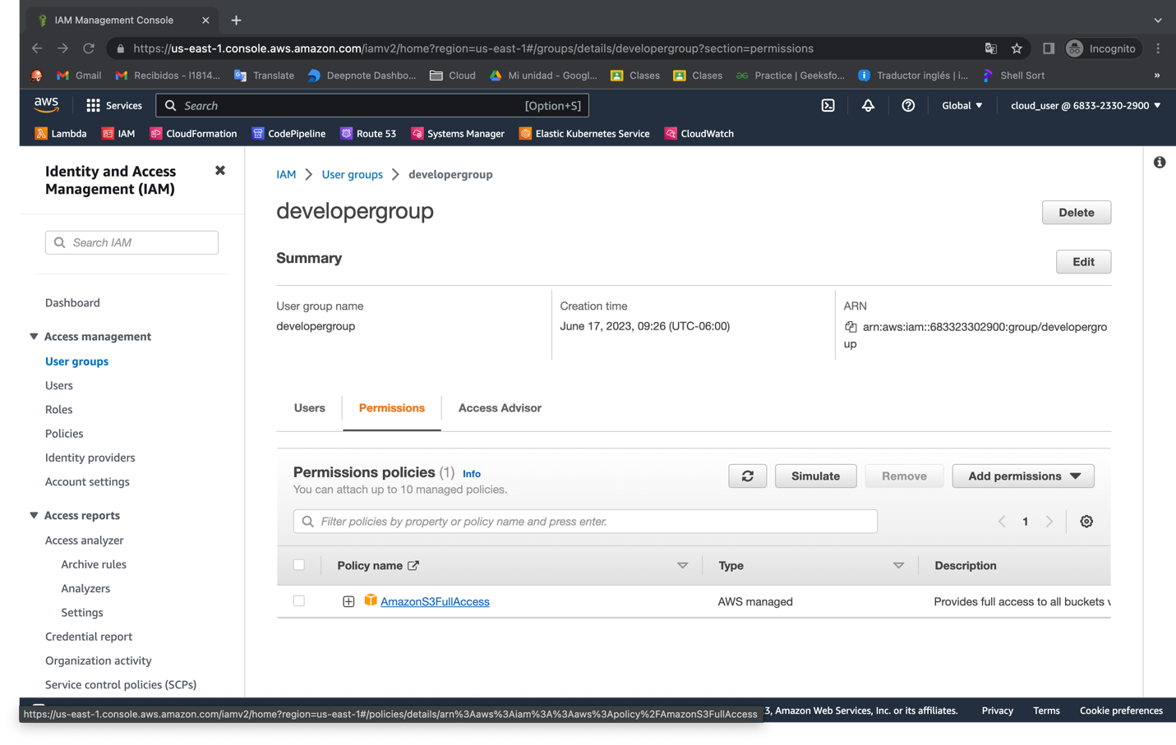

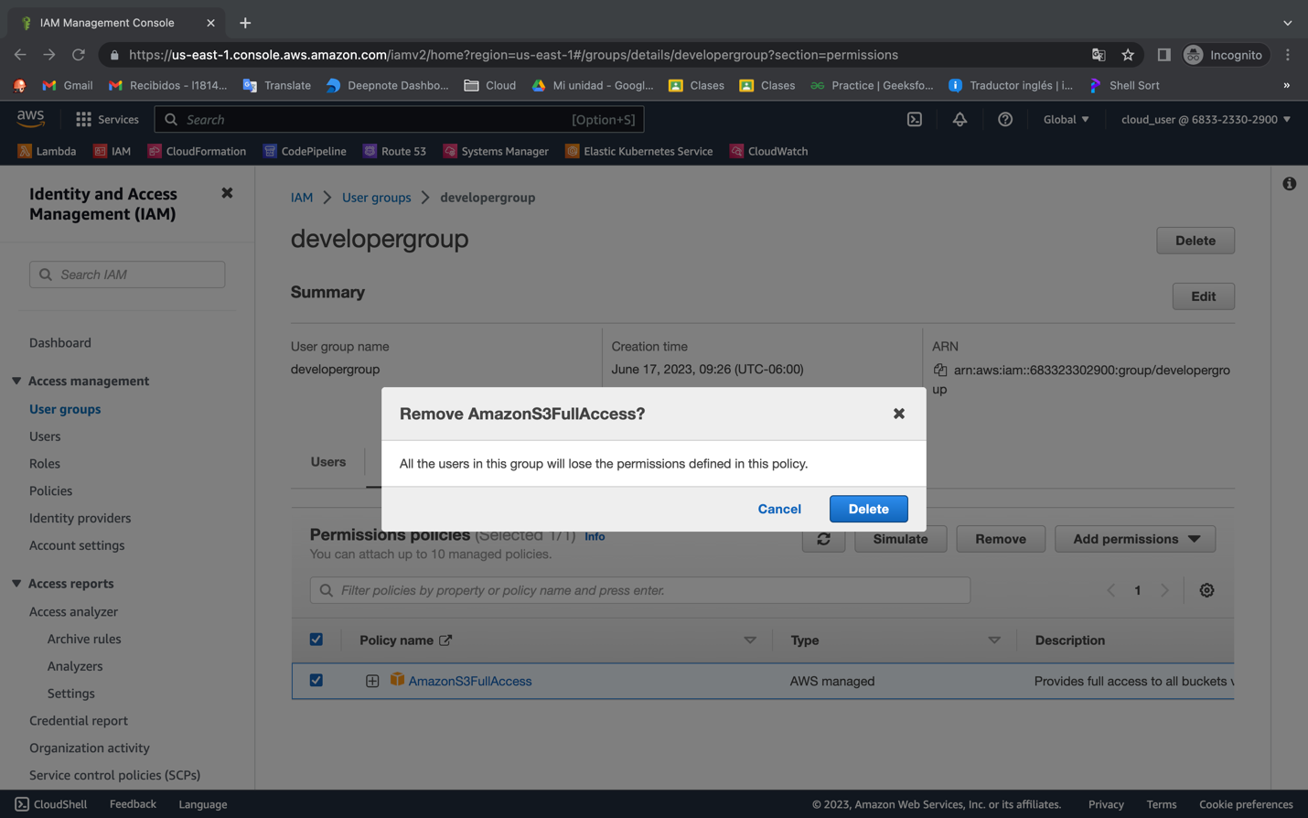

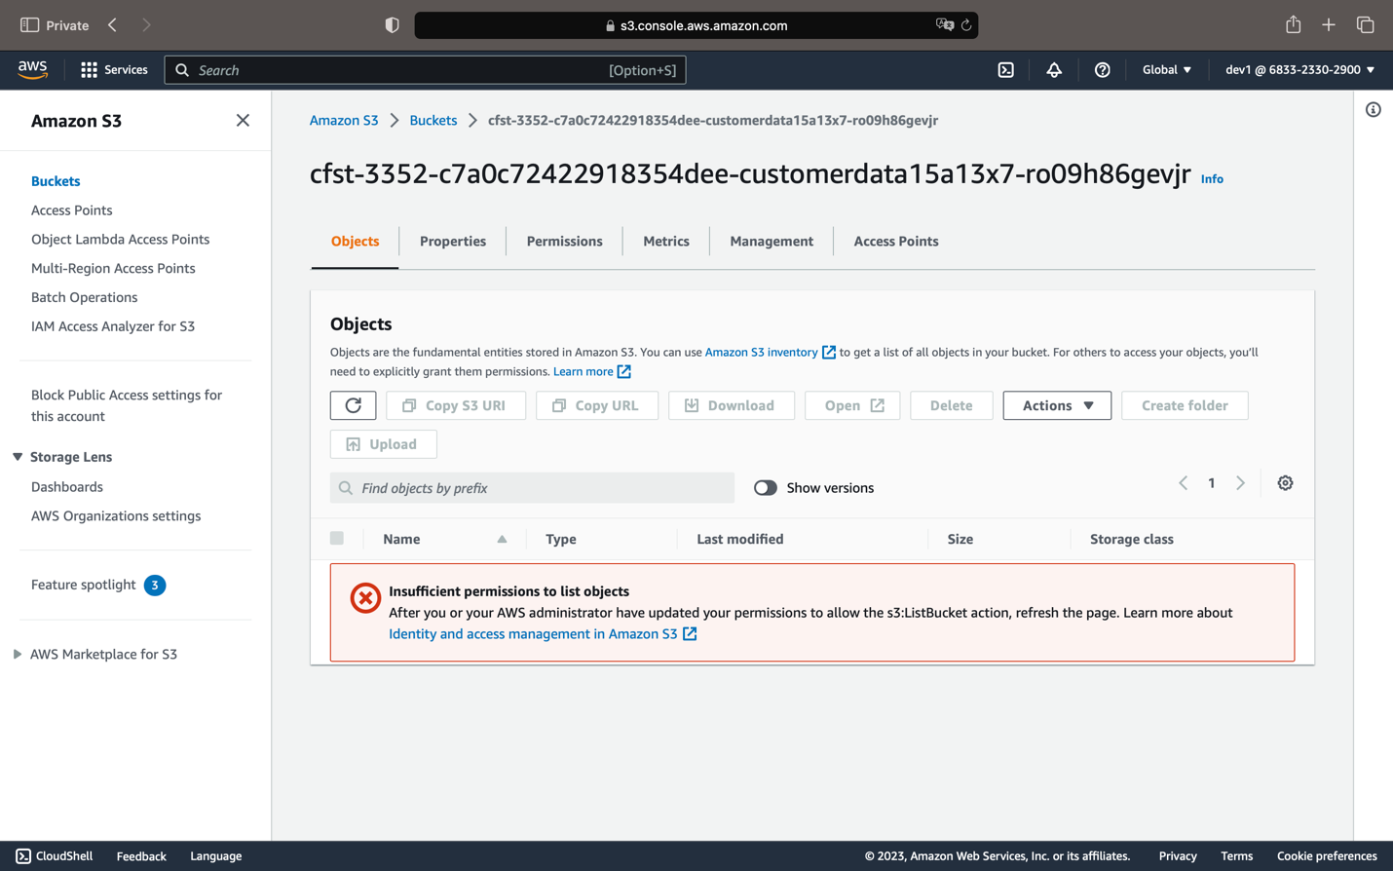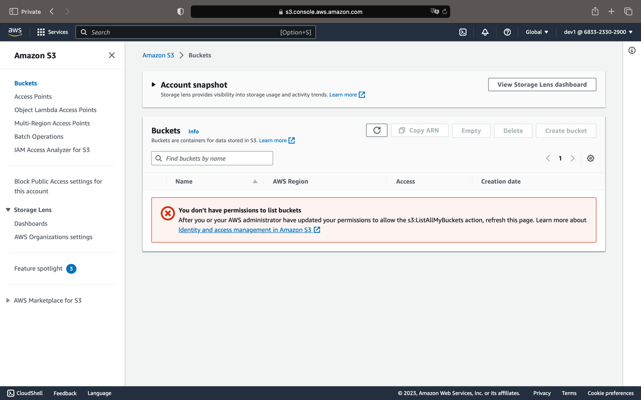

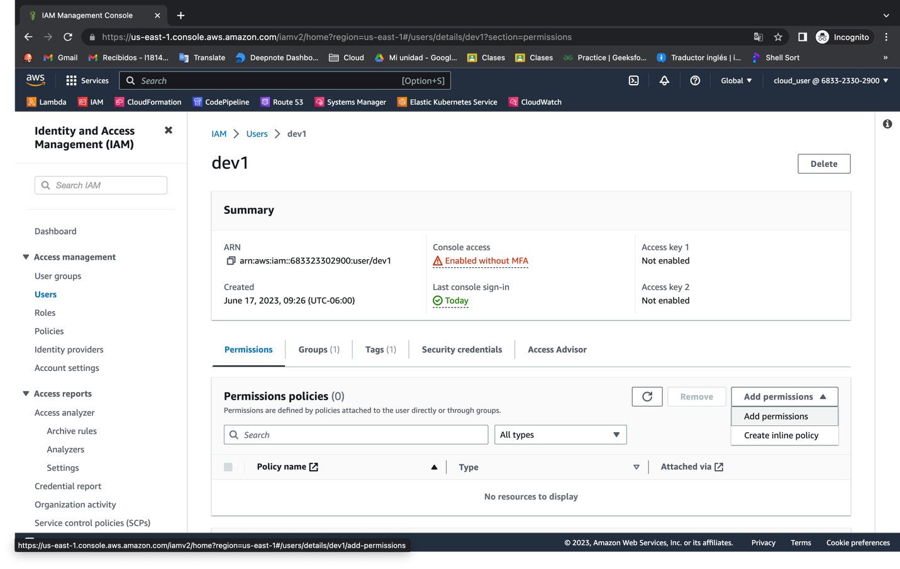

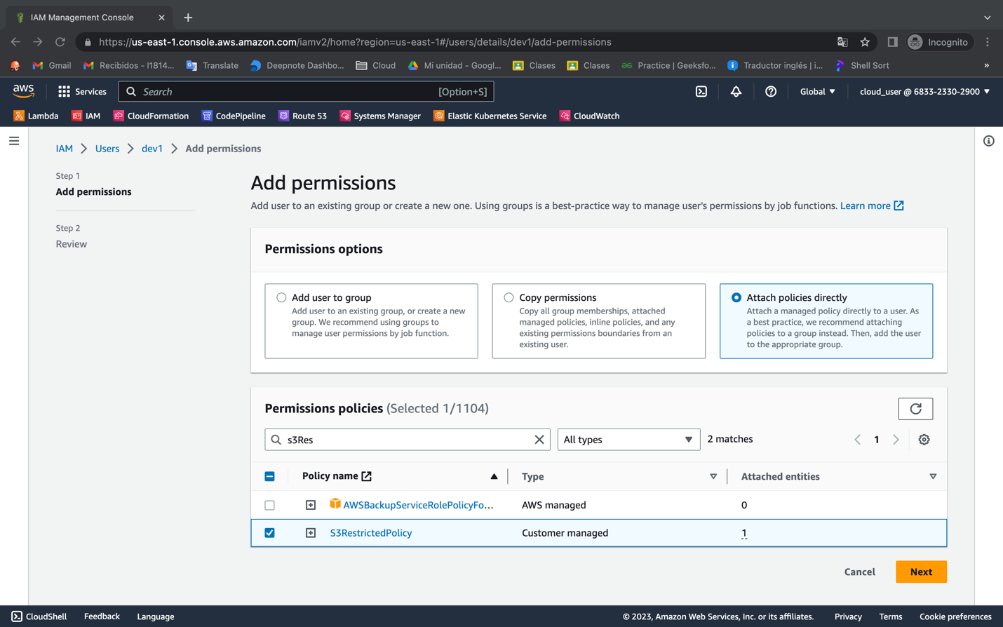

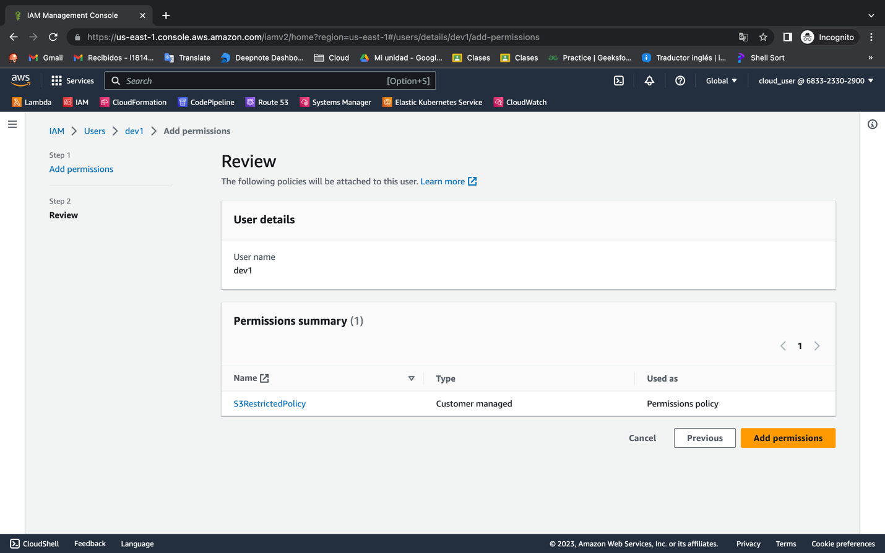

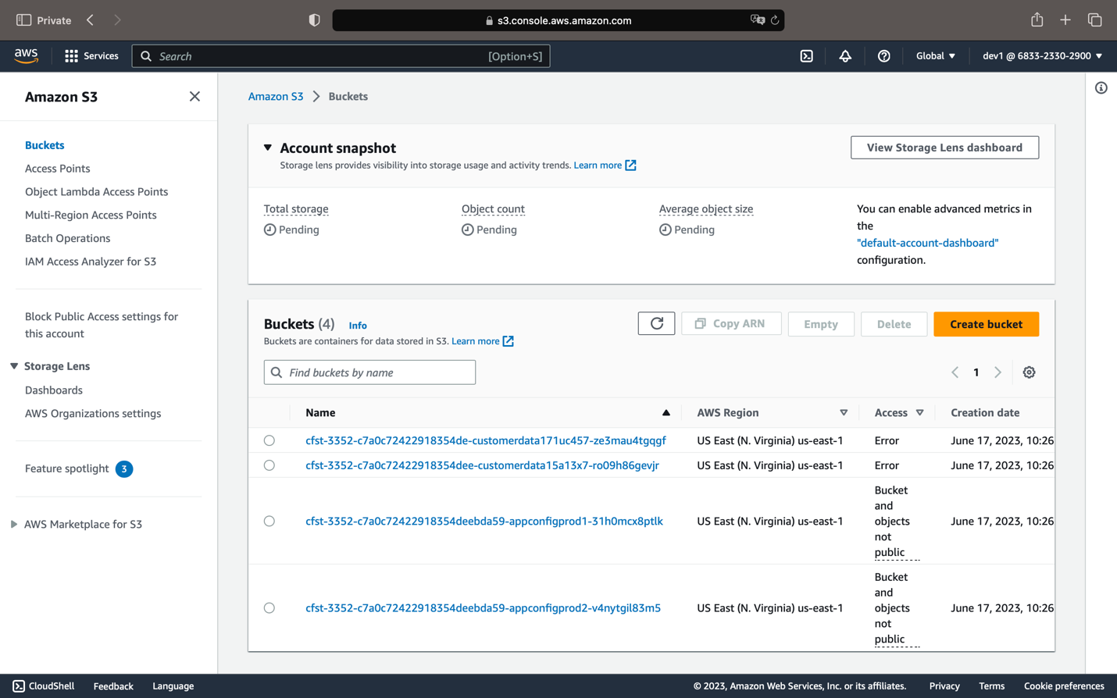



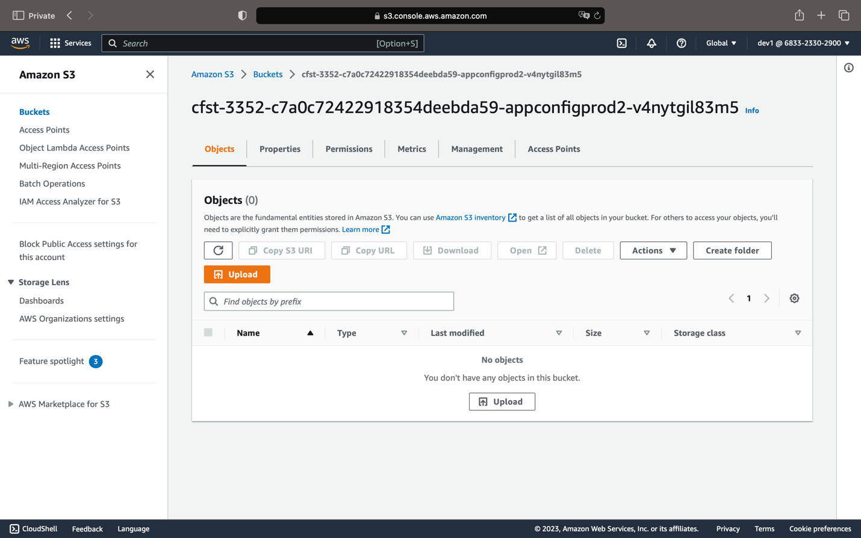

Dev3

